* Dropdown menu not working.

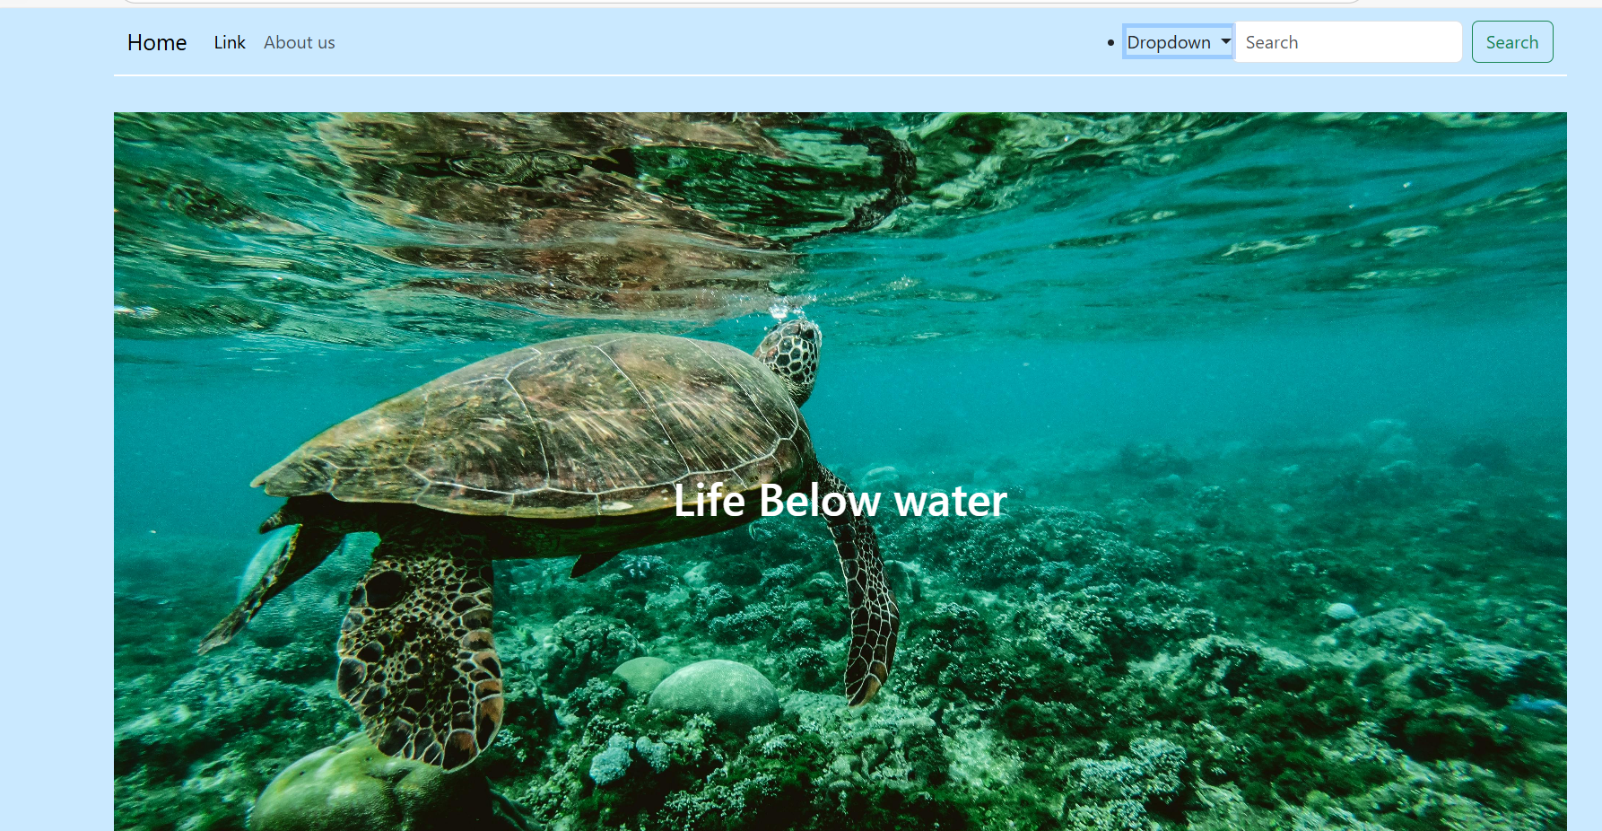

* Navbar sectioned and organised, still not working properly

* Sticky navbar working

